STM32 ENVIRONMENT MONITORING CONTROLLER
STM32 BLOCK DIAGRAM

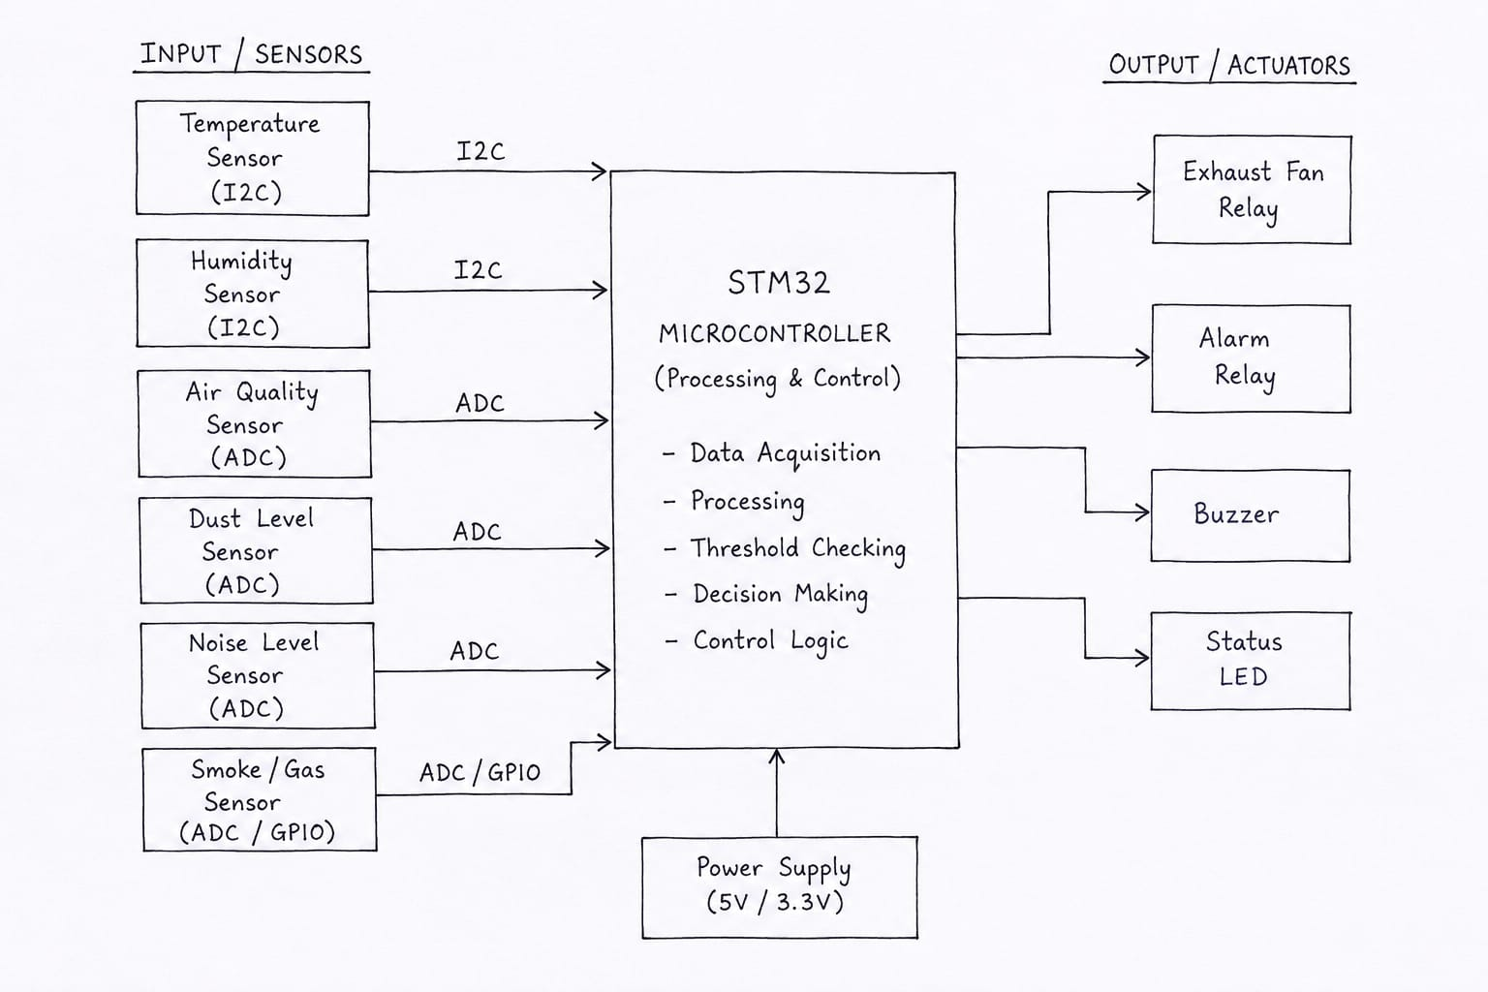
STM32 FIRMWARE FLOWCHART
